**Beckett, Samuel Barclay (1906 -1989)**

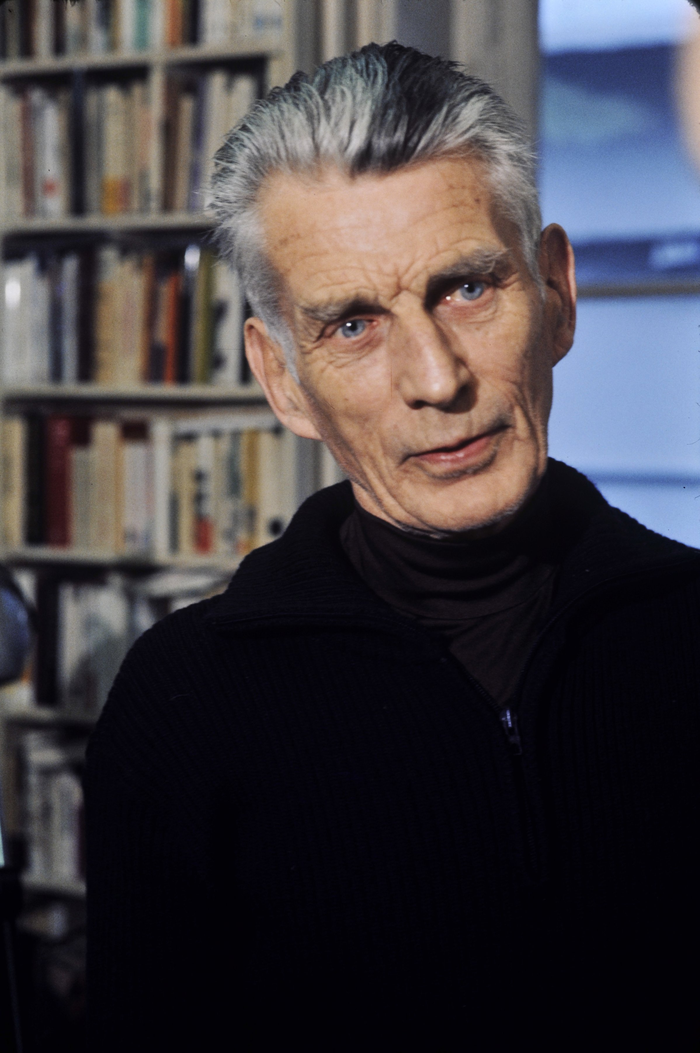**Summary**

Samuel Barclay Beckett is widely considered one of the most influential writers of the twentieth century. Born in Ireland and living in France for half of his life, he wrote prose, dramatic works, poems, and criticism in both English and French. He started to write fiction after he met James Joyce and other intellectuals in Paris in the 1920s. His research on languages, literature, and philosophy at Trinity College, Dublin, and at École Normale Supérieure provided a solid basis for his works. His popularity grew rapidly after the Second World War, particularly after the publication of his groundbreaking play, *En attendant Godot* (1953, *Waiting for Godot*), and his trilogy, *Molloy* (1951), *Malone meurt* (1951, *Malone Dies*), and *L’innommable* (1953, *The Unnamable*). He was not only a prolific modernist who innovated avant-garde prose, theatre, radio, television, and cinema; he also joined the French Resistance during the Second World War and the post-war reconstruction. He won the Nobel Prize for Literature in 1969.

Samuel Beckett, by Roger Pic - Bibliothèque nationale de France. Licensed under Public Domain via Wikimedia Commons –

<http://upload.wikimedia.org/wikipedia/commons/0/09/Samuel_Beckett,_Pic,_1.jpg>

**Main Entry**

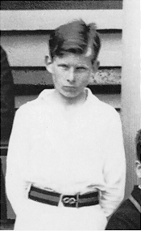Samuel Barclay Beckett was born to Bill Beckett, a quantity surveyor, and May Beckett (Maria Jones Roe), a nurse, at Cooldrinagh in Foxrock, Dublin. The true date of his birth is debatable, though the public records show that he was born on Good Friday, 13 April 1906. He was the second son in a Protestant family, a quiet and thoughtful child who loved collecting stamps. At the age of fourteen, he was sent to Portora Royal School where he began to reveal his talent for language and sports.

In 1923, Beckett began to study at Trinity College, Dublin, for the bachelor’s degree in Modern Languages. Besides studying for his Honours subjects, French and Italian, he kept up Latin and completed two years of English literature courses. He read European literature widely and often went to theatres. His early novel *Murphy* (1938) reveals the shadow of the Abbey Theatre and some of J. M. Synge’s tragicomic elements. Beckett completed the bachelor’s degree in 1927.

Young Beckett, via Samuel Beckett: Apmonia - url:

<http://www.themodernword.com/beckett/images/beckett_photos/young_cricketeer.gif>

In 1928, Beckett went to the École Normale Supérieure in Paris. His stay in Paris led to his meeting with James Joyce, Thomas MacGreevy (who later became Beckett’s confidant), and other intellectuals. Through MacGreevy, Beckett became a research assistant for Joyce’s ‘Work in Progress’ (later *Finnegans Wake*) and was invited to write an essay for *Our Exagmination Round His Factification for Incamination of Work in Progress*. This essay, entitled ‘Dante … Bruno. Vico .. Joyce’, is one of Beckett’s most important pieces of criticism. It was published together with his first short story, ‘Assumption’, an innovative fiction about the impulse of screams, in the magazine *transition* in June 1929. The following year, the Hours Press published Beckett’s first poem, ‘Whoroscope’. This long poem has ninety-eight lines, and smartly alludes to the life of Descartes. Soon after this publication, Beckett completed *Proust*, a critical study of Proust’s *À la recherche du temps perdu* (*In Search of Lost Time*) along with a discussion of Schopenhauer’s philosophy.

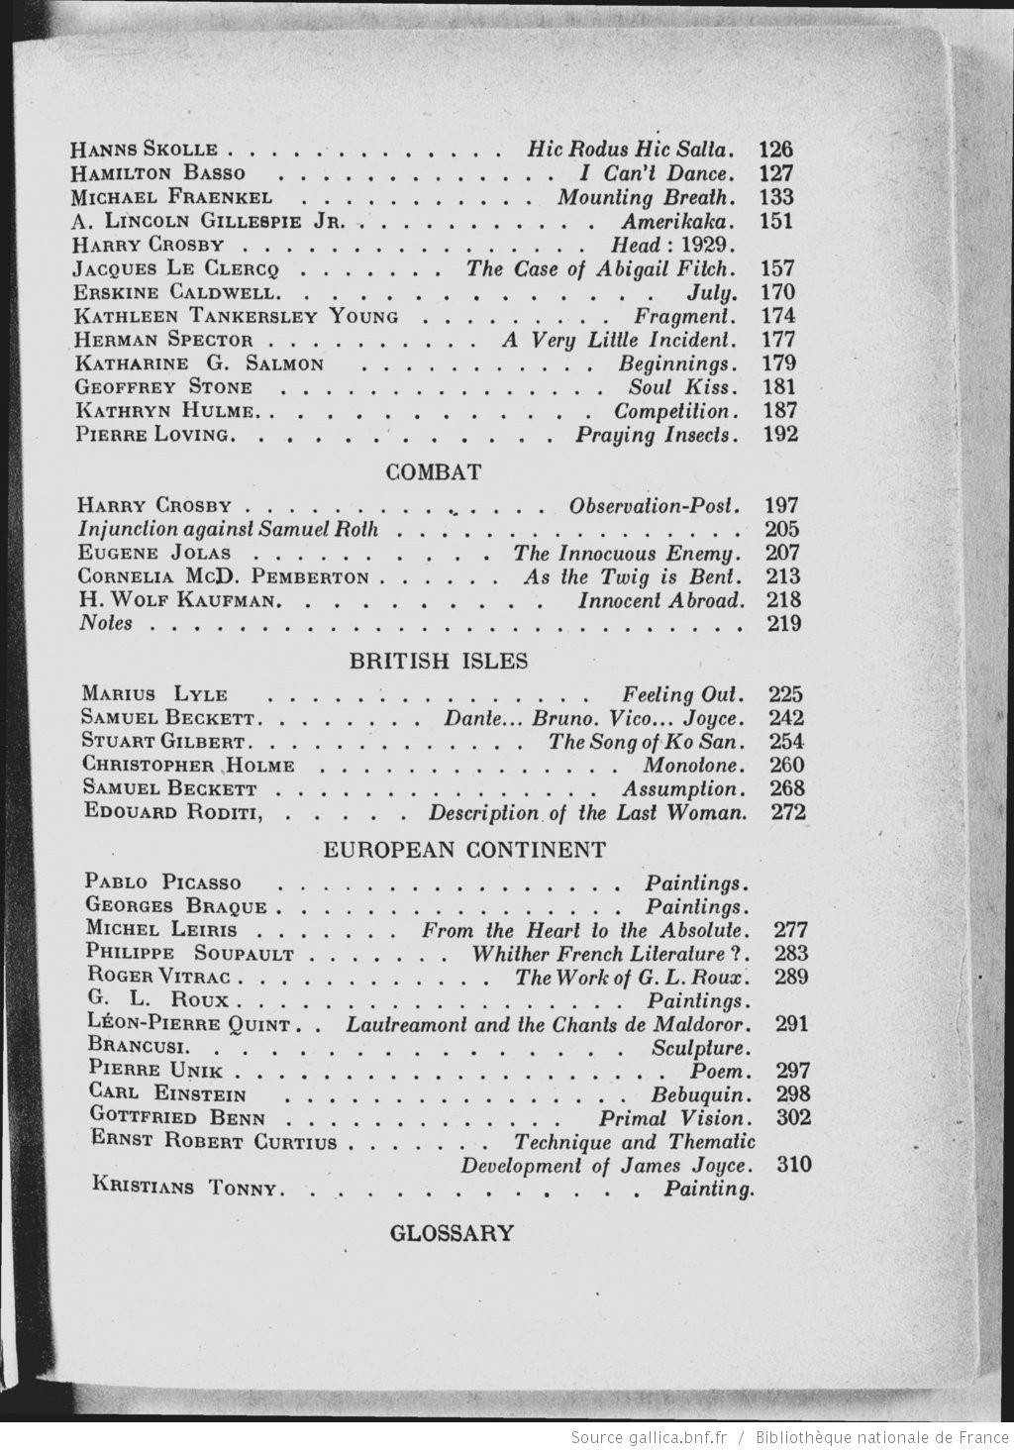

Beckett continued to write fiction after he returned to lecture at Trinity in 1930. Due to his estrangement from his mother, among other reasons, he resigned from Trinity and went to Paris in 1932. He stayed at the Trianon Palace and spent most of his time writing his first novel, *Dream of Fair to Middling Women* (whose title was partly borrowed from Tennyson’s *A Dream of Fair Women*). The novel tells the story of Belacqua (a name in Dante’s *Purgatorio*) and his relationship with three women, the Smeraldina-Rima, the Syra-Cusa, and the Alba. Using very sophisticated language, Beckett wove many quotations from literary works, philosophy, and theology into an incoherent narrative structure. The novel was rejected by publishers and only published posthumously in 1992.

*transition*, issue June, 1929, the table of content that included Beckett’s essay and his first short story, via scans in Gallica-<http://gallica.bnf.fr/ark:/12148/bpt6k6241490w.image.langEN.r=transition>

Image url: <http://gallica.bnf.fr/ark:/12148/bpt6k6241490w/f14.highres>

After his father’s death, Beckett was overcome with grief and left for London in 1933. The London years from 1933 to 1936 witnessed the publication of Beckett’s short story collection *More Pricks than Kicks* (1934),and the completion of his novel *Murphy*. During his stay in London, Beckett also underwent psychotherapy and was exposed to psychological studies through his therapist Bion and C. G. Jung’s lectures, as well as through reading Freud, Adler, and the Külpe School. Much of Beckett’s knowledge about psychology appeared in *Murphy*, a novel that he finished in 1936 but did not publish until 1938. Set in London, *Murphy* deals with a tragicomic hero Murphy who struggles to find jobs and maintain his relationship with a prostitute named Celia. The novel ends with the death of Murphy in a mental hospital. In the same year of the completion of *Murphy*, Beckett travelled to Germany and recorded his experience in six notebooks—the ‘German diaries’ as critics have called them. Between 1936 and 1937, Beckett was widely exposed to German literature and visual art. At the same time, he witnessed Hitler’s purge of modern art.

After his permanent settlement in Paris in 1937, he was near-fatally stabbed by a pimp. In the process of recovery, Beckett not only received help from Joyce, but also met Suzanne Deschevaux-Dumesnil, who later became his life partner (and wife in 1961). Beckett and Suzanne joined the French Resistance in 1941 when France was invaded. After their cell was betrayed, they had to leave for Rousillion, a southern village in France. Beckett worked on a farm and continued to write his novel *Watt*, begun earlier in Paris. *Watt* marked Beckett’s further departure from his early works such as *Dream of Fair to Middling Women* and *Murphy,* as well as from the influence of Joyce’s writing. *Watt* features a character called Watt, who mysteriously appears at a railway station, goes through a series of events in Mr. Knott’s house, and disappears again. The excessively mathematical representation in this novel stresses Beckett’s mockery of rationality that had been revealed earlier in his ‘Les deux besoins’, an essay written in 1938 but unpublished until 1983 in *Disjecta*.

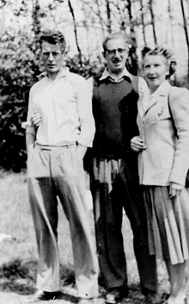

In France, (left to right) Samuel Beckett, his bother Frank, and Suzanne Dechevaux-Dumesnil

Via: <http://www.emory.edu/EMORY_MAGAZINE/issues/2012/winter/of_note/beckett.html>

Image url:

<http://www.emory.edu/EMORY_MAGAZINE/issues/2012/winter/images/art/beckett.jpg>

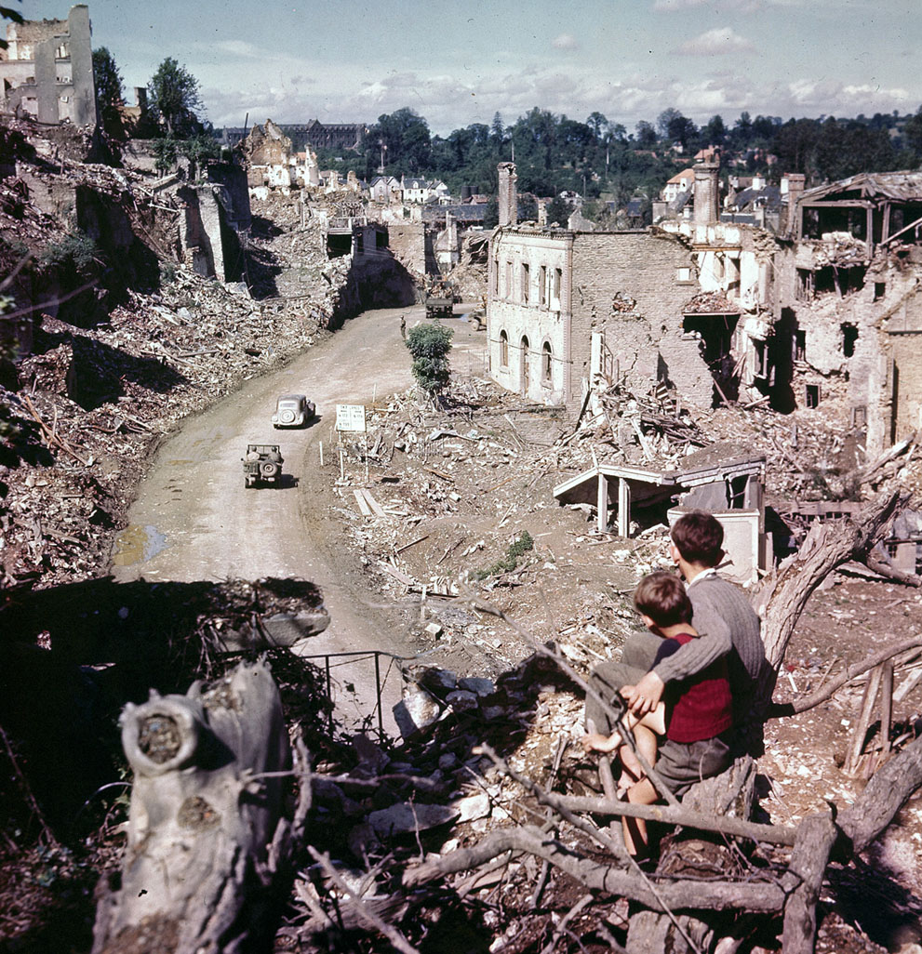After the Second World War, Beckett and Suzanne returned to Paris and joined the Irish Red Cross hospital set up in Saint-Lô. The devastating scene of the heavily bombed Saint-Lô shocked Beckett. His radio speech in 1946, entitled ‘The Capital of the Ruins’, shows his sympathy for the people in Saint-Lô. The post-war years, from 1946 to 1953, witnessed the completion of Beckett’s several most significant works: the trilogy (*Molloy*, *Malone Dies*, *The Unnamable*) and *Waiting for Godot*. Written in four months in 1946, *Mercier et Camier* was Beckett’s first novel in French and it largely prefigured *Molloy*. In the same year, Beckett approved the French translation of *Murphy* and a contract for future works both in English and French, which officially marked the beginning of Beckett’s bilingual writing career. In the following three years, Beckett worked strenuously on the trilogy in French: *Molloy* (1951), *Malone meurt* (1951), and *L’innomamable* (1953). The French editions were followed by Beckett’s own English translations published in 1955, 1956, and 1959. *Molloy* contains two chapters, dealing with two main characters, Molloy and Moran, respectively. It begins with Molloy’s first-person narrative about his experience on the way to his mother’s apartment. When Molloy ends up staying in a ditch at the end of the first chapter, Moran, a detective in the second chapter, launches his search for Molloy. *Malone Dies* constructs a tension between Malone’s experience in a room and his growing difficulty in narrating his stories. Main characters in Malone’s stories change from Sapo to Macmann, along with Moll and other minor characters. In *The Unnamable*, the anonymous narrator claims the authorship of several characters from Beckett’s previous works, such as Murphy, Mercier, Molloy, Malone, and Macmann. The consistent use of ‘m’ for names implies a lasting desire to return to the absent matrix—the ‘mahood’ as the narrator calls it. *The Unnamable* does not have a fixed plot or setting. Its intractable narrative ends with the famous sentence, ‘You must go on, I can’t go on, I’ll go on’. The trilogy demonstrates Beckett’s unique style of writing and his interrogation of narrative and language.

Saint-Lô after bombing – may be copyrighted <http://tomclarkblog.blogspot.ca/2013/10/samuel-beckett-saint-lo.html>

Image url:

<http://cdn.theatlantic.com/static/infocus/ww2_16/s_w43_40701064.jpg>

Beckett’s most well known work, the play *En attendant Godot* (*Waiting for Godot*), was written between 1948 and 1949 when he was working on the trilogy. Although Beckett’s turn to theatre began as early as 1947 when he completed a play called *Eleutheria*, *Waiting for Godot* was chosen by Beckett and the director Roger Blin as Beckett’s first play performed in the Théâtre de Babylone, Paris. According to Beckett himself, *Waiting for Godot* was partly inspired by Caspar David Friedrich’s painting, *Man and Woman Contemplating the Moon*. The play has two acts; in each act two main characters, Vladimir and Estragon, wait for Godot to come. In each act, they encounter three characters, Pozzo, Lucky, and a boy, but Godot does not appear at all throughout the play. This play shows Beckett’s effort to extend the possibility of theatre to a new level and to challenge the conventions of drama.

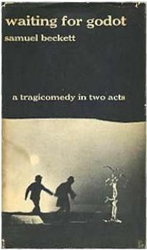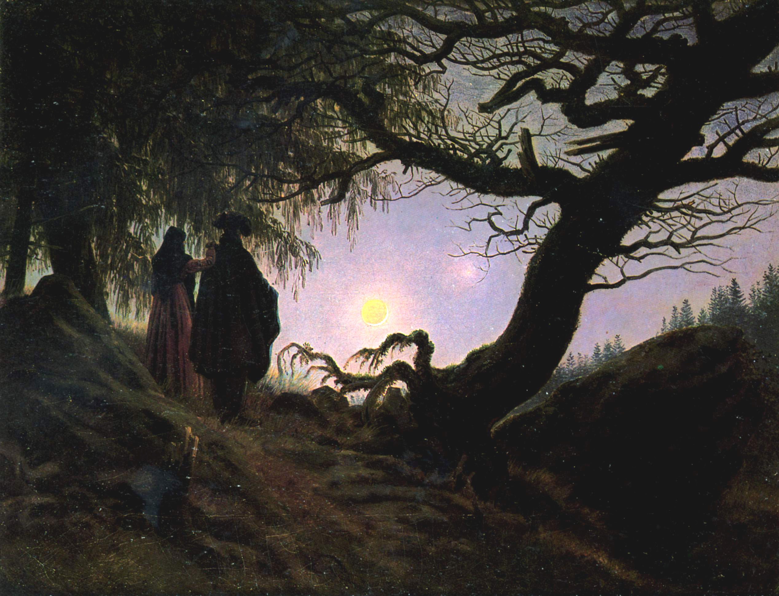

The first English edition of *Waiting for Godot* - ‘WaitingForGodot’ by Source. Licensed under Fair use via Wikipedia - http://upload.wikimedia.org/wikipedia/en/9/9a/WaitingForGodot.JPG

*Man and Woman Contemplating the Moon,* Caspar David Friedrich - Licensed under Public Domain via Wikimedia Commons - <http://upload.wikimedia.org/wikipedia/commons/b/bf/Caspar_David_Friedrich_-_Mann_und_Frau_in_Betrachtung_des_Mondes_-_Alte_Nationalgalerie_Berlin.jpg>

The 1950s and 1960s continued to witness Beckett’s success in dramatic works, such as *Fin de partie (*1957, *Endgame*), *Fragment de théâtre I* (*Rough for Theatre* *I*)*,* *Fragment de théâtre II* (*Rough for Theatre* *II*), *Krapp’s Last Tape* (1958), *Happy Days* (1962), and shorter prose. In 1969, he received the Nobel Prize for Literature, though he was not particularly interest in awards and public attention. Beckett first turned to radio plays in 1956 when he wrote *All That Fall* for the BBC. In the 1970s and the 1980s, Beckett further extended his dramatic works to teleplays for the BBC and continued writing prose, such as *The Lost Ones*, *Company*, *Ill Seen Ill Said*, and *Worstward Ho. ‘*Stirrings Still’, written in 1986, is his last major work of prose. Although writing was considerably difficult for Beckett at that time, he insisted on translating it into French. He died peacefully on Friday, 22 December 1989.

**Video and Audio**

Interview in 1987

<http://www.openculture.com/2010/04/samuel_beckett_speaks.html>

Samuel Beckett reads from his novel *Watt*: <http://www.openculture.com/2013/03/rare_audio_samuel_beckett_reads_two_poems_from_his_novel_iwatti.html>

Beckett in Berlin, 1969, by Rosa veim and Daniel Schmid

https://www.youtube.com/watch?v=85rr-h_pqcA

‘Beckett Directs Beckett’ (1985). With the San Quentin Players, Samuel Beckett directed in person his three plays, *Waiting for Godot*, *Krapp’s Last Tape*, and *Endgame*.

* *Endgame*: <https://youtu.be/VD_JkAJ-OAk>
* *Krapp’s Last Tape*: <https://youtu.be/af5NohyiQrA>
* *Waiting for Godot* (separate parts): <https://www.youtube.com/playlist?list=PLxh2dDIXgEs_x-n84dv2oqoIEry2plD11>

The official website of ‘Beckett Directs Beckett’: <http://mith.umd.edu/beckett/index.php>

From *Molloy* – Sucking Stones – BBC television

<https://youtu.be/TXoq_H9BrTE>

‘A Wake for Sam’, a tribute to Samuel Beckett, BBC television, January 1990‬

<https://youtu.be/qHo_594up6o>

Audio: Beckett’s radio play ‘Embers’, 1963 broadcast

<https://archive.org/details/pra-IZ1214>

‘Not I’, by Samuel Beckett, the premiere, 1973

<https://youtu.be/M4LDwfKxr-M>

*Quad I+II* (teleplay)

<https://youtu.be/4ZDRfnICq9M>

Edward Albee and Paul Auster Discuss Samuel Beckett

<https://youtu.be/oywUVlLo1Zs>

(Paul Auster is the general editor of the Grove Centenary Edition of *Samuel Beckett*; Edward Albee, J.M. Coetzee, Salman Rushdie, and Colm Tóibín wrote introductions for this four-volume edition)

**List of Works**

**Collected Works**

*Samuel Beckett: The Complete Dramatic Works* (Faber and Faber, 1986)

*Samuel Beckett* (The Grove Centenary Edition, 2006), 4 vols.

*The Collected Poems of Samuel Beckett* (Faber and Faber, 2012)

**Prose**

The list follows the chronology of the publication of the first edition, with some dates of composition included, given that some of Beckett’s early works did not get published until the end of the Second World War.

**Fiction**

*Murphy* (1938); French version (1947)

*Molloy* (1951); English version (1955)

*Malone meurt* (1951); *Malone Dies* (1956)

*L’innommable* (1953); *The Unnamable* (1959)

*Watt* (1953; written 1944); French Version (1968)

*Comment c’est* (1961); *How It Is* (1964)

*Mercier et Camier* (1970, written 1946); *Mercier and Camier* (1974)

*Dream of Fair to Middling Women* (1992; written 1932)

**Short Prose Fiction**

‘Assumption’ (1929)

‘Sedendo et Quiescendo’ (1932)

‘A Case in a Thousand’ (1934)

*More Pricks Than Kicks* (1934)

*Nouvelles et textes pour rien* (1955); *Stories and Texts for Nothing* in *No’s Knife* (1967)

‘From an Abandoned Work’ (1956)

‘Imagination morte imaginez’ (1965); ‘Imagination Dead Imagine’ (1965)

‘Assez’ (1966); ‘Enough’ (1967)

‘Bing’ (1966); ‘Ping’ (1967)

‘Sans’ (1969); ‘Lesseness’ (1970)

*‘Le Dépeupleur*’(1970); ‘*The Lost Ones’* (1972)

‘Premier Amour’ (1970; written 1946); ‘First Love’ (1973)

‘Still’ (1974)

‘As the Story Was Told’ (1975)

*Pour finir encore et autres foirades* (1976); *For to End Yet Again and Other Fizzles* (1976)

*Company* (1980)

*Mal vu mal dit* (1981); *Ill Seen Ill Said* (1982)

*Worstward Ho* (1983)

‘Stirrings Still’ (1989)

**Non-fiction**

‘Dante … Bruno . Vico .. Joyce’ (1929), in *Our Exagmination Round His Factification for Incamination of Work in Progress*

*Proust* (1931)

*Three Dialogues* (1949)

*Disjecta: Miscellaneous Writings and a Dramatic Fragment* (1983)

**Poetry Collections**

*Whoroscope* (1930)

*Echo’s Bones and other Precipitates* (1935)

*Poems in English* (1961)

*Poèmes* (1968)

*Collected Poems in English and French* (1977)

**Theatre**

*En attendant Godot* (1952); *Waiting for Godot* (1956)

*Acte sans Paroles I* (1956); *Act Without Words I* (1957)

*Acte sans Paroles II* (1956); *Act Without Words II* (1957)

*Fin de partie* (1957); *Endgame* (1957)

*Krapp's Last Tape* (first performed 1958)

*Fragment de théâtre I* (late 1950s); *Rough for Theatre I*

*Fragment de théâtre II* (late 1950s); *Rough for Theatre II*

*Happy Days* (1962); *Oh les beaux jours* (published 1963)

*Cascando* (1963)

*Play* (1963); English version (1964)

*Come and Go* (1966)

*Breath* (1969)

*Not I* (1972)

*That Time* (1976)

*Footfalls* (1976)

*A Piece of Monologue* (1979)

*Rockaby* (1981)

*Ohio Impromptu* (1981)

*Catastrophe* (*Catastrophe et autres dramatiques*, 1982)

*What Where* (1983)

*Human Wishes* (1984)

*Eleuthéria* (1995, written 1947 in French); English version (1996)

**Radio**

*All That Fall* (1957)

*Embers* (1959)

*Words and Music* (1962)

*Cascando* (1963); *Cascando*, in *Play and Two Short Pieces for Radio* (1964)

*Rough for Radio I* (1976) (written in French in 1961 as *Esquisse radiophonique*)

*Rough for Radio II* (1976) (written in French in 1961 as *Pochade radiophonique*)

**Television**

*Eh Joe with Jack MacGowran* (1966)

*Beginning to Eng with Jack MacGowran* (1965)

*Ghost Trio* (1977)

*Quad I+II (1981)*

*Nacht und Träume* (1983); *Night and Dreams* (1984)

**Cinema**

*Film* (1965)

**Biographies and Memoirs**

Bair, Deirdre, *Samuel Beckett: a Biography* (London: Jonathan Cape, 1978)

Juliet, Charles, *Rencontre avec Samuel Beckett* (Paris: Editions Fata Morgana, 1986)

Knowlson, James, *Damned to Fame: The Life of Samuel Beckett* (London: Bloomsbury, 1996)

Knowlson, James, and Elizabeth Knowlson. *Beckett Remembering, Remembering Beckett: A Centenary Celebration* (New York: Arcade Pub., 2006).

**Letters**

*The letters of Samuel Beckett*, 3 vols (Cambridge UP, 2009-)

*No Author Better Served: the Correspondence of Samuel Beckett & Alan Schneider* (Harvard UP, 1998)

**Further Reading**

Cronin, Anthony. *Samuel Beckett: The Last Modernist*. London: HarperCollins, 1996.

Gibson, Andrew. *Samuel Beckett*. London: Reaktion Books, 2010.

Gontarski, S.E., ed. *A Companion to Samuel Beckett*. Chichester: Wiley-Blackwell, 2010.

Gontarski, S.E., and Anthony Uhlmann, eds. *Beckett after Beckett*. Gainesville: UP of Florida, 2006.

Graver, Lawrence, and Raymond Federman, eds. *Samuel Beckett: The Critical Heritage*. London: Routledge & K. Paul, 1979.

Huge, Kenner. *Samuel Beckett: A Critical Study*. New York: Grove Press, 1961.

Mercier, Vivian. *Beckett/Beckett*. Oxford: Oxford UP, 1977.

Nixon, Mark. *Samuel Beckett’s German Diaries 1936-1937*. London: Continuum, 2011.

Pilling, John. *Samuel Beckett*. London: Routledge & Kegan Paul, 1976.